1)
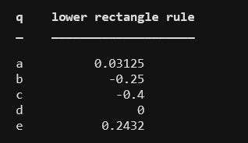

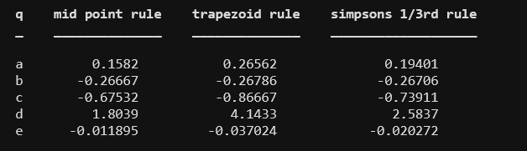
2)

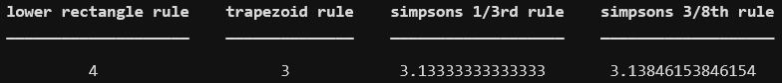
3)

4)ans=7.125

5)

f(x)=xln(x)
f’(x)=1+ln(x)
f’’(x)=1/x
f’’’(x)=-1/x²
f’’’’(x)=2/x⁴

max_{1<=x<=2} f’’(x)=1
max_{1<=x<=2} f’’’’(x)=2

Here m=10⁻⁵
(actual-calculated)/actual<=±m
(actual-calculated)/calculated<=(1/(1±m)-1)
actual-calculated=error

a) Composite Trapezoidal rule:
error=(-h²(b-a)/12)f’’(c_{n})<=(-h²/12)
n=115
h=0.0086
area=0.636298728771027

b)Composite Simpson’s rule:
error=(-h⁴(b-a)/180)f’’(c_{n})<=(-h⁴/90)
n=7
h=0.1428
area=0.636294469092996

c)Composite Midpoint rule:
error=(-h²(b-a)/24)f’’(c_{n})<=(-h²/24)
n=81
h=0.0123
area=0.636289959200426

6)length of the track in feet is(using composite trapezoid rule):9855

